**Gridboy Contract Details**

Total Price is based on proration of Annual Rate and co-termed End Date

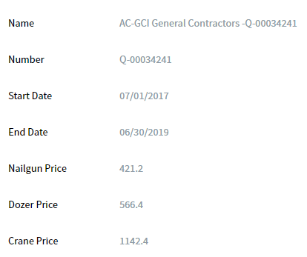

**Salesforce Opportunity Line Items**

Each time an order is placed via the Admin Console a line item is created on the open “Console AddOn” Opportunity

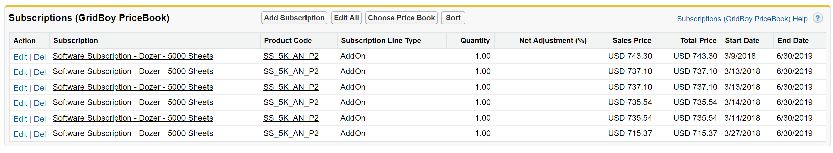

**NetSuite Sales Order Line Items**

When “Console AddOn” Opportunity is Booked in SFDC and synced a NetSuite Order is created.

Manual Billing Schedules are created for each line item (A, B, C, D). If the line item is the same term and same amount, a custom Billing Schedule can be re-used (eg. Schedule B & C are used on multiple lines).

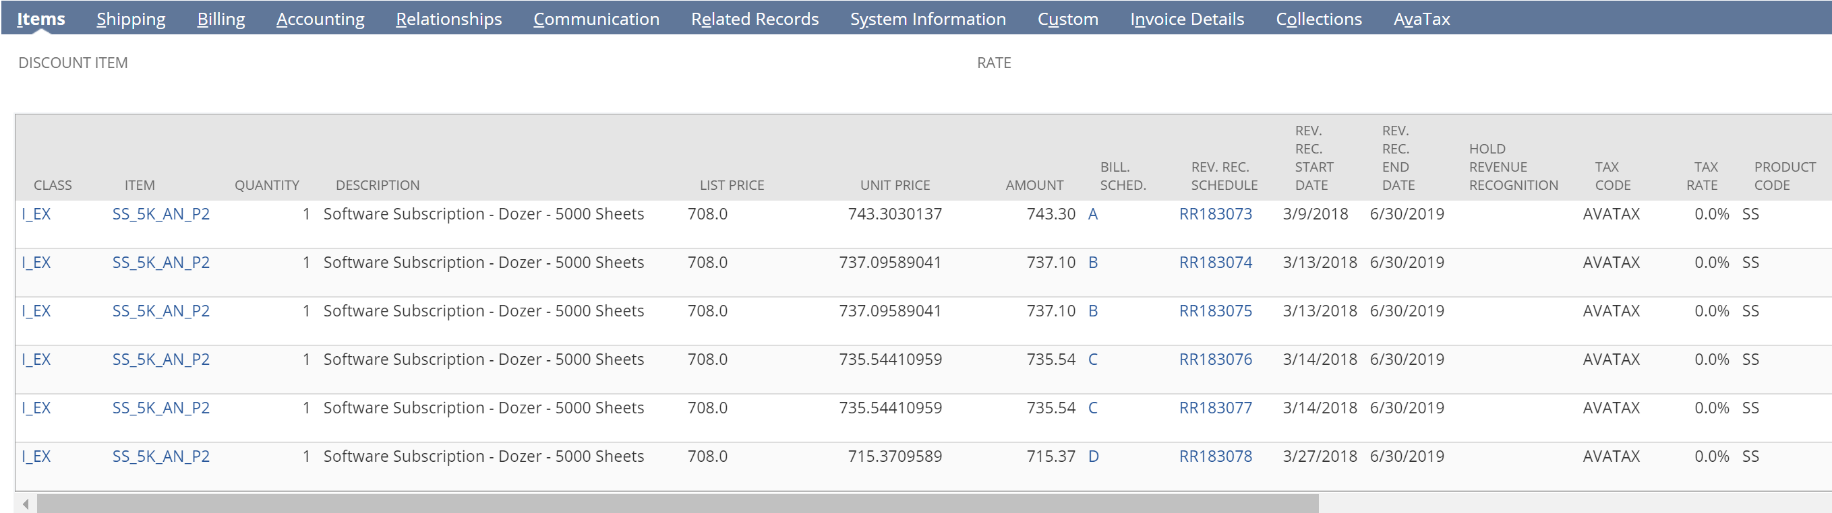

**NetSuite Custom Line Item Billing Schedules**

Schedule A, B, C, D

Last Bill is the full annual rate for the line item. First Bill is the remainder (prorated) amount.

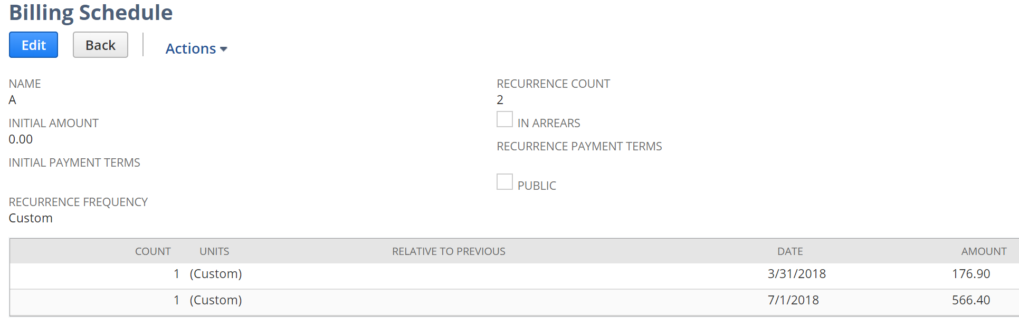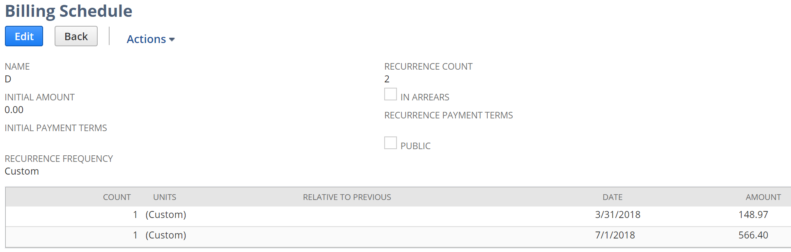

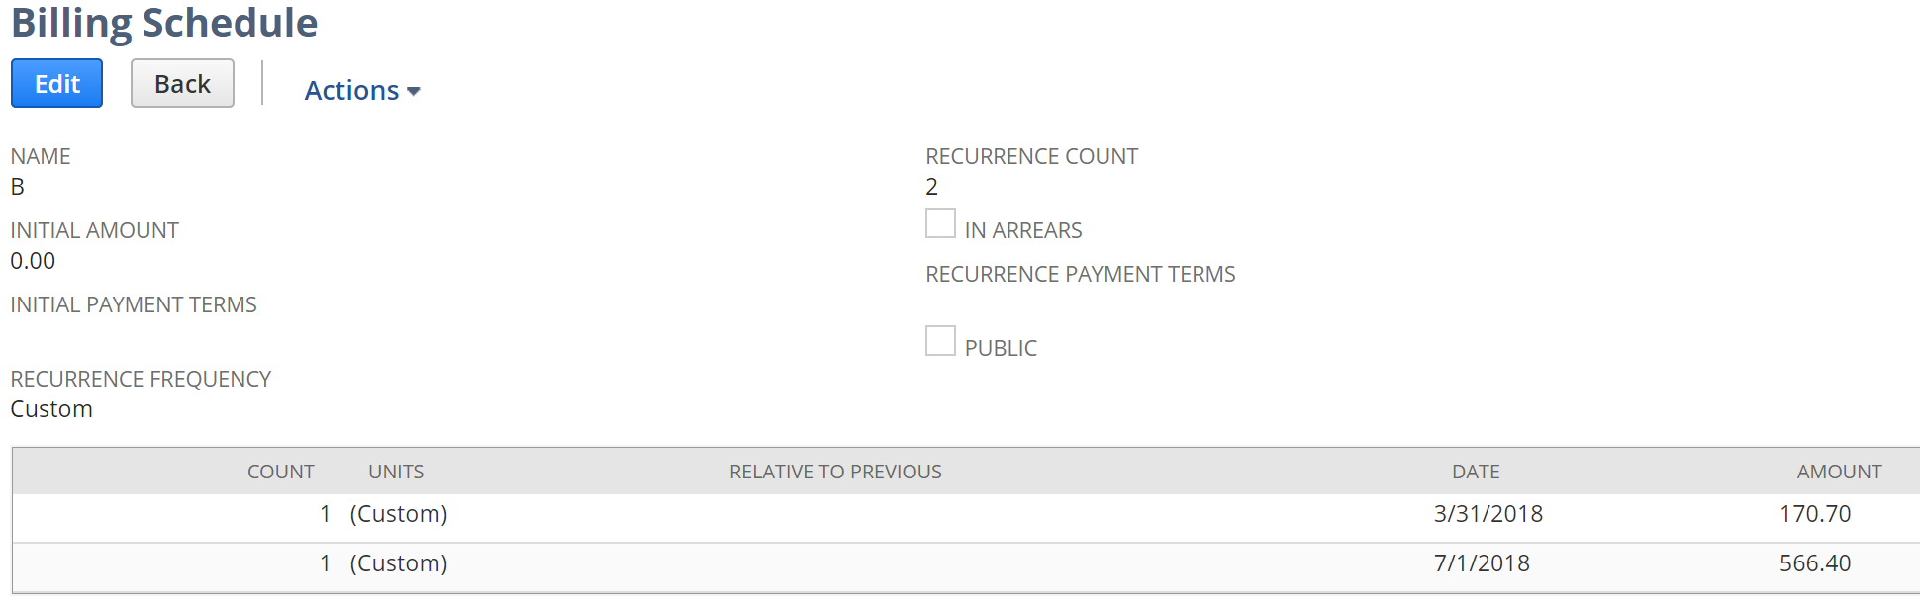

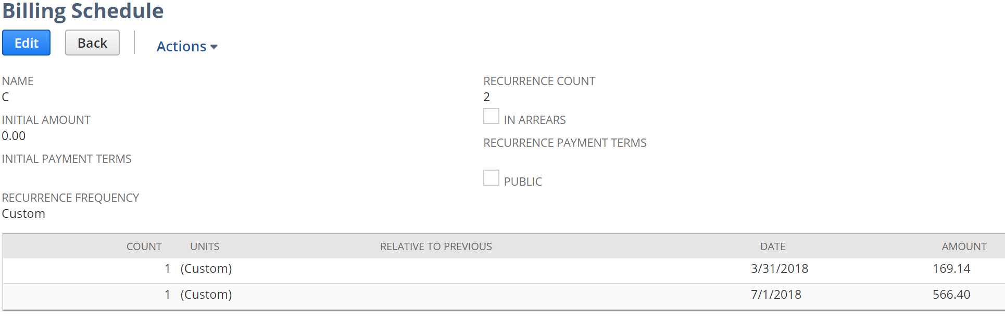



**NetSuite Total Bills Scheduled**

After custom billing schedules created for each line item, the total order’s billing schedule is complete.

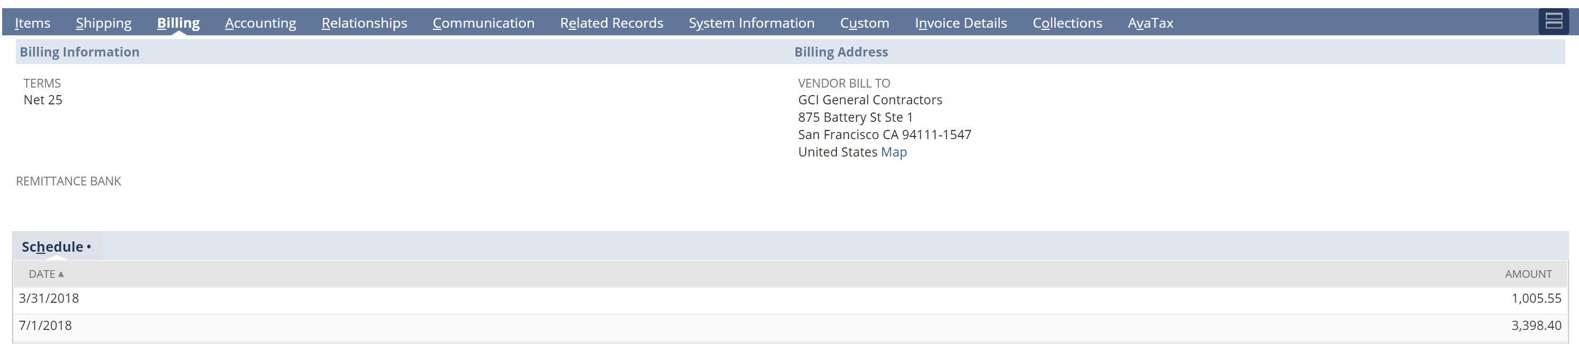

**NetSuite Invoice Line Items**

First bill is then manually generated, based on the Billing Schedule proration

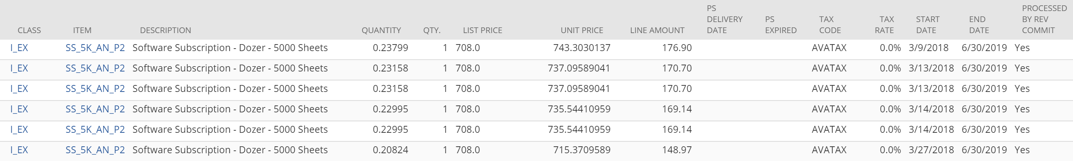

**NetSuite Invoice Template**

The invoice template shows the full order term from the Sales Order line items.

Enhancement:

Display what bill# this is and how many total bills are scheduled (eg. Installment 1 of 2)

Display the Billing Term (eg. March 2018 to June 30, 2018)

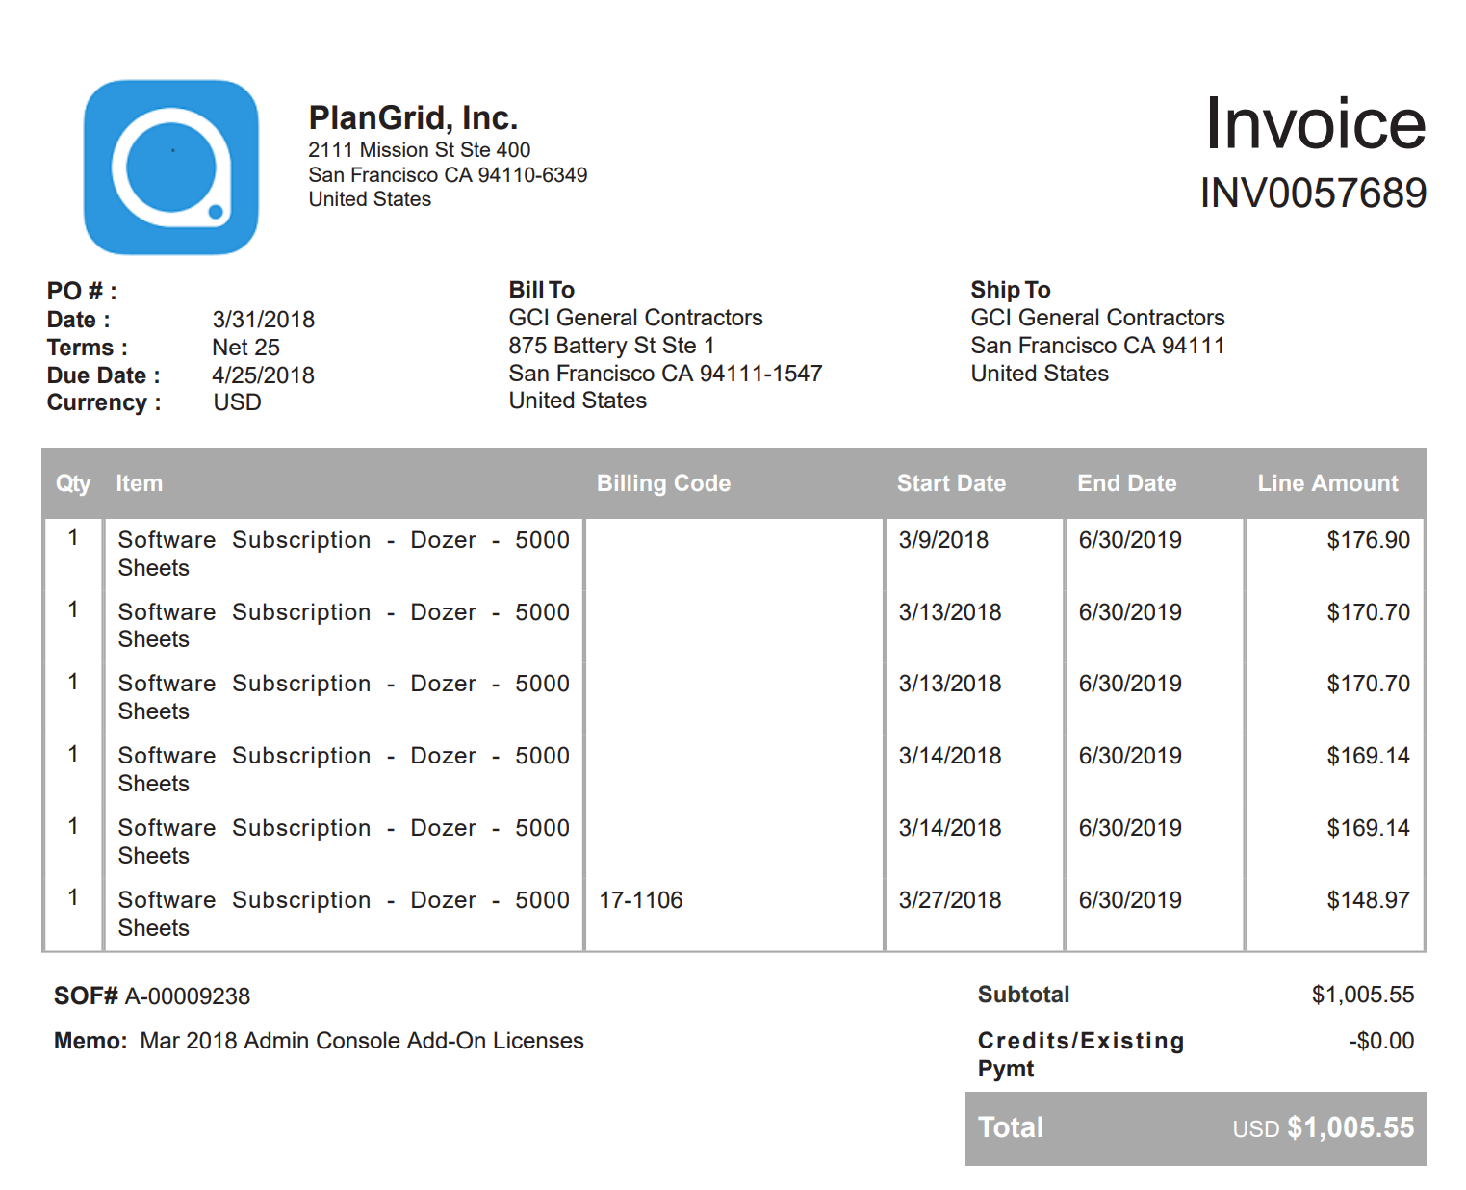

**Excel calculation of billing schedule**

Line Item Breakdown on calculating bill amount

